**Page 1 (Heap Concepts)**

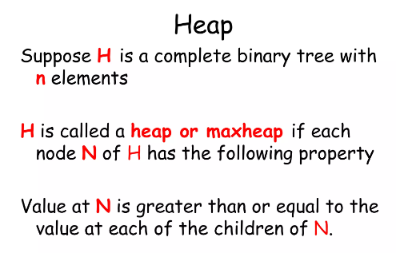

**Page 2 (Heap Concepts)**

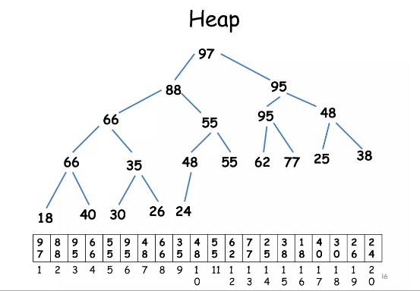

**Page 3 (Heap Concepts)**

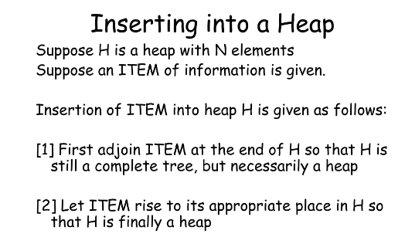

**Page 4 (Heap Concepts)**

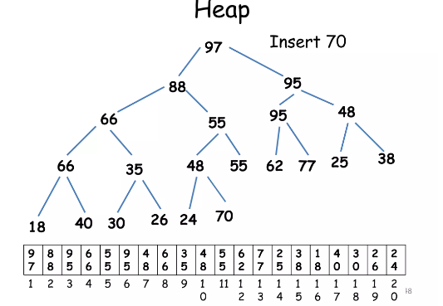

**Page 5 (Heap Concepts)**

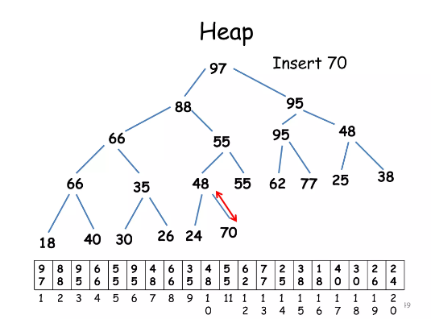

**Page 6 (Heap Concepts)**

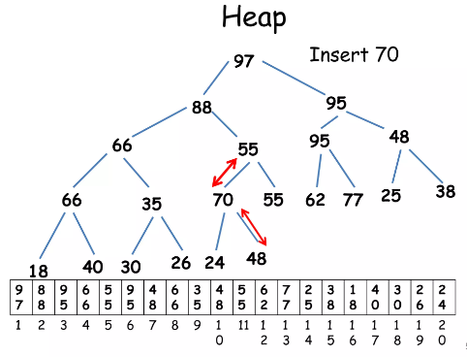

**Page 7 (Heap Concepts)**

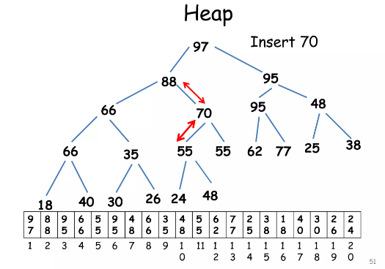

**Page 8 (Heap Concepts)**

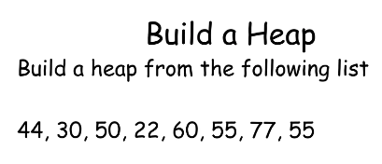

**Page 9 (Heap Concepts)**

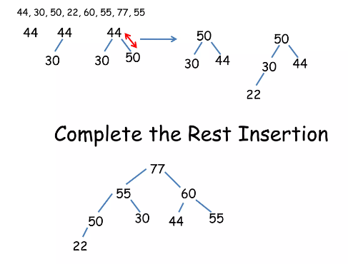

**Page 10 (Heap Concepts)**

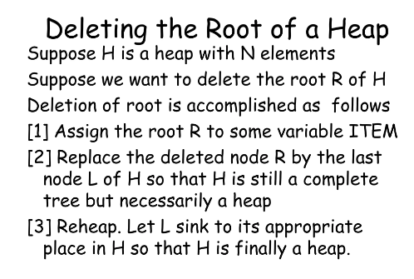

**Page 11 (Heap Concepts)**

